Hard coding

Hard coding is a concept of providing values directly

The main disadvantage of hard coding is it always generates same output.

But if we want to generate any different output we have to perform several operations repeatedly like open the program, change the required values, save the program, compile and execute again.

It is always recommend removing the hard coding in the real time applications.
To remove Hard coding we can use different methodologies like reading values from key board, reading values from a file, reading values from a text box, using command line arguments,....

Command line arguments

Command line arguments means the values that we pass to main() method at command line or command prompt.

The line where we give the command is known as command-line. It is an imaginary line and nothing but the command prompt. It is another style of giving values to the program at runtime.
Here arguments are passed at running time (not readily at compile time); the traditional way is through method calls and taking input from keyboard. This requires the knowledge of parsing operations where a string is converted to a data type.

The main advantage of command line arguments is to remove hard coding.

//wap to demo on command line arguments

class Demo{
public static void main(String[] args){
int a,b,c;
a=Integer.parseInt(args[0]);
b=Integer.parseInt(args[1]);
c=a+b;
System.out.println("Addition="+c);
}
}

compilation
javac Demo.java
Case 1:
java Demo 120 210
Output: 330

Case 2:
java Demo
RuntimeException:

Case 3:
Java Demo a b
RuntimeException:Java.lang.NumberFormatException: For input string: “a”

We can enter multiple command line arguments which are separated by space

We can enter multiple command line arguments of any type but it will take in the format of String.

But if we want to get our original data or values we have to use "parsing "

Parsing

Parsing is a process of converting a string into required primitive type.

Eg:
Byte.parseByte();
Short.parseShort();
Integer.parseInt();
Long.parseLong();
Float.parseFloat();
Double.parseDouble();
Character.parseCharacter(); X – invalid (this method is not available)
Boolean.parseBoolean();

As a programmer we are responsible only for declaring String array in main() method.

String array can be created by JVM and size will be decided by number of command line elements .
String array name can be anything

Eg:
String[] args
String data[]
String xyz[]

Why main() method takes String array only as parameter

If main() method takes integer array then we can enter only integer values as command line arguments or if main() method takes double array then we can enter only double values as command line arguments But if main() method takes String array then we can enter any type of value but we require parsing to convert into required type.

Eg:
class Cmd1{
public static void main(String[] data){
System.out.println("No of Arguments: "+data.length);
for(int i=0;i<data.length;i++){
System.out.println(data[i]);
}
}
}
Eg:
class Cmd2{
public static void main(String[] data){
int total=0;
for(int i=0;i<data.length;i++){
total = total + Integer.parseInt(data[i]);
}
System.out.println("total="+total);
}
}

Following program is on passing Java command-line arguments.

public class Test{
public static void main(String[] balaji){
System.out.println("Element count: " + balaji.length);
System.out.println("2nd argument passed: " + balaji[1]);
System.out.println("\nRetrieving the elements passed");
for(int i=0; i<balaji.length; i++){
System.out.print(balaji[i] + " ");
}
System.out.println("\n\nFinding product after Parsing");
int x = Integer.parseInt(balaji[0]);
double y = Double.parseDouble(balaji[1]);
System.out.println("1st argument: " + x);
System.out.println("2nd argument: " + y);
System.out.println("1st and 2nd arguments product: " + x*y);
}
}

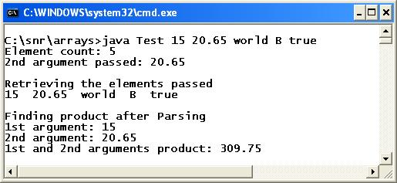

Let us see the writing the source code, compilation and execution. Writing the soruce code and compilation is as usual and as follows.
c:\snr\arrays> notepad Test.java // writing the source code
c:\snr\arrays> javac Test.java // compilation
c:\snr\arrays> java Test 15 20.65 world B true // execution

public static void main(String[] balaji)

Observe, the args is changed to balaji. Moreover, the square brackets are placed before the array object balaji which Java permits. After all, args is only an array object name which can be anything.

15, 20.65, world, B and true are the arguments passed, say, as command-line arguments. As long as you are concerned, they may be an integer, a double, a string etc. But they are converted into strings and passed to balaji array existing in the main() method. This is done implicitly by the JVM as balaji is a string array and an array stores similar data type value.

int x = Integer.parseInt(balaji[0]);
double y = Double.parseDouble(balaji[1]);

balaji[0] and balaji[1] are in string form and it is required to parse them (converting into data types) as they are used in product evaluation. With strings, printing can be done but not useful for arithmetic operations.

class CommandLineArguments{
public static void main(String args[]){
if(args.length == 0){
System.out.println("Running the program with no arguments");
}
else if(args.length == 1){
System.out.println("Running the program with one argument - " + args[0]);
}
else if(args.length == 2){
System.out.println("Running the program with two argument - " + args[0] + " and " + args[1]);
}
else{
System.out.println("Invalid number of arguments only 0 or 1 or 2 arguments accepted.");
}
}
}

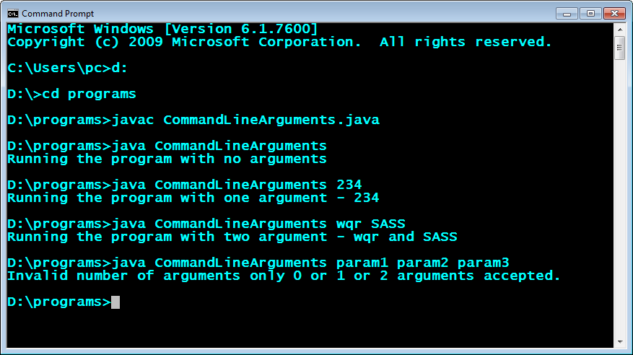

class EchoName{
public static void main(String s[]){
System.out.println("Hello " + s[0]);
}
}

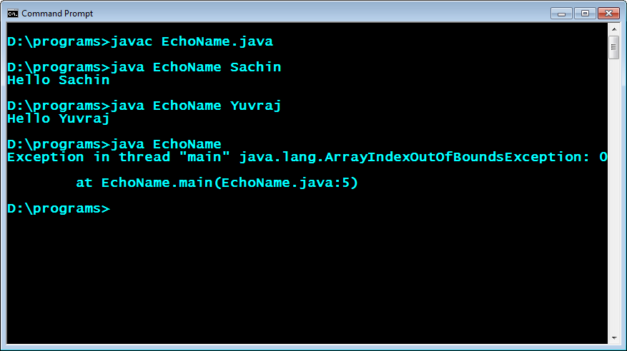

The arguments which are passing from command prompt are called as “Command Line Arguments”.

The main objective of command line arguments are we can customize the behavior of the main() method.

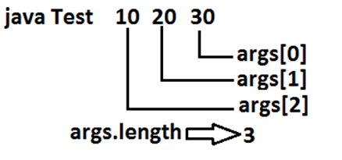
Note:
- The group of strings what we are passing as an argument to the main method from the console or command line are known as command line arguments.
- Every command line argument would be accepted by the JVM in the form of a String object.
- JVM will always executes main method by passing object of an array of strings.
- JVM would never execute main method by passing null
- JVM always executes main as a thread.
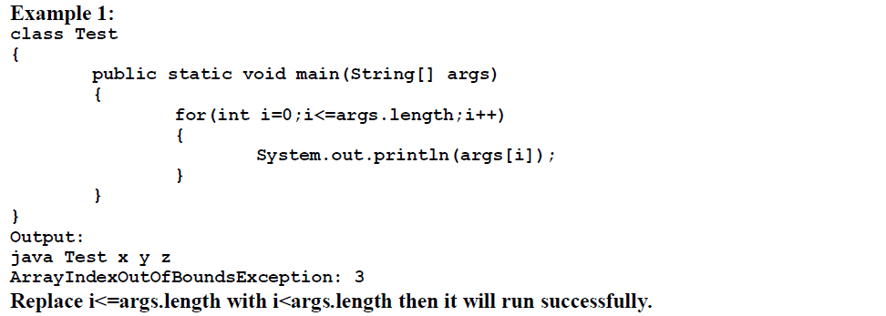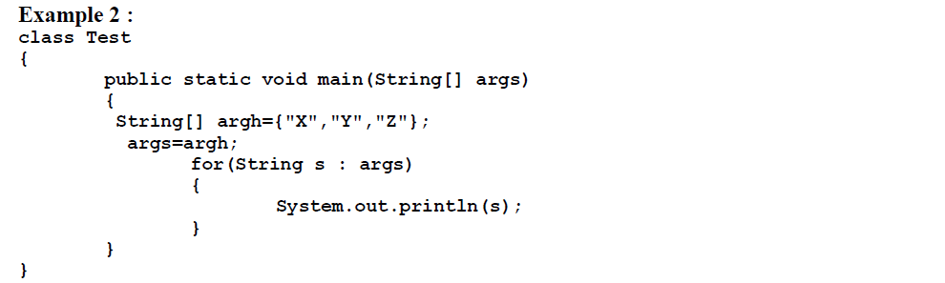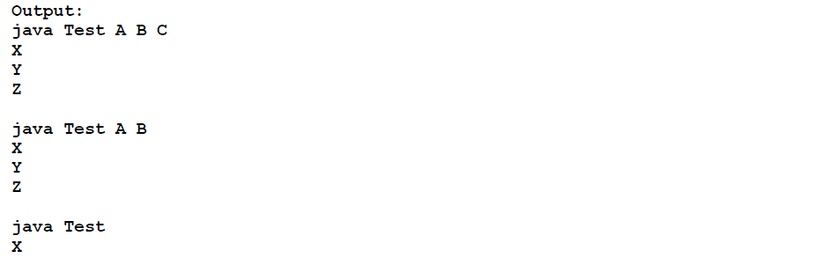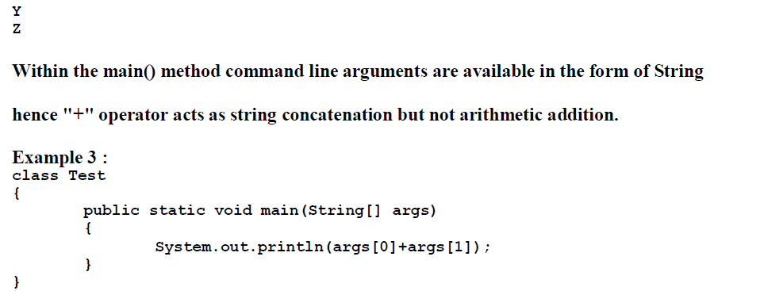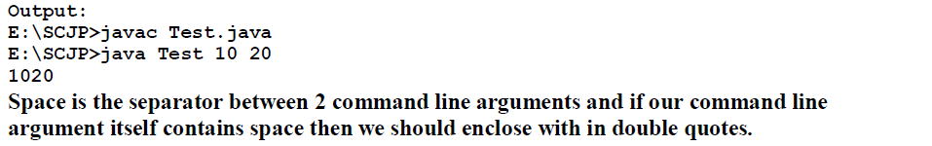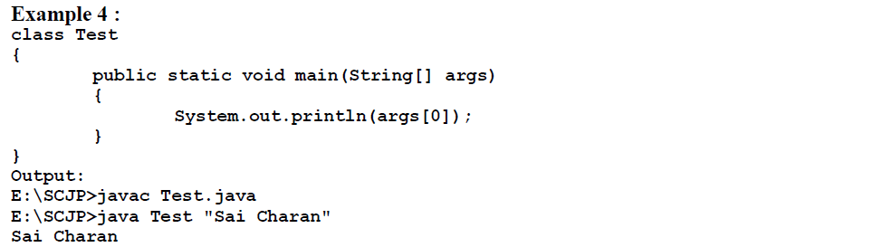

What is the difference between java command line arguments and C command line arguments?
- In C and C++, the system passes two arguments to a program: argc and argv. argc specifies the number of arguments stored in argv. argv is a pointer to an array of characters containing the actual arguments. In Java, the system passes a single value to a program: args. args is an array of Strings that contains the command-line arguments.
- In C the argument counter starts from the program name itself.
But in the case of Java the argument count starts after the classname
for eg: java testArg rao rao1
the arg[0] is "rao " here(in Java )
But in the case of C it comes to "testArg"

If I do not provide any arguments on the command line, then the String array of main() method will be empty or null?
It is empty. But not null.
What is the first argument of the String array in main() method?
The String array is empty. It does not have any element. This is unlike C/C++ where the first element by default is the program name.
What if I do not provide the String array as the argument to the method?
Program compiles but throws a runtime error "NoSuchMethodError".
What if I write static public void instead of public static void?
Program compiles and runs properly.
What if the main() method is declared as private?
The program compiles properly but at runtime it will give "main() method not public." message.
What if the static modifier is removed from the signature of the main() method?
Program compiles. But at runtime throws an error "NoSuchMethodError".
How can one prove that the array is not null but empty using one line of code?
Print args.length. It will print 0. That means it is empty. But if it would have been null then it would have thrown a NullPointerException on attempting to print args.length.
Can an application have multiple classes having main() method?
Yes it is possible. While starting the application we mention the class name to be run. The JVM will look for the Main method only in the class whose name you have mentioned.
Hence there is not conflict amongst the multiple classes having main() method.
Can I have multiple main() methods in the same class?
No the program fails to compile. The compiler says that the main() method is already defined in the class
Do I need to import java.lang package any time? Why ?
No. It is by default loaded internally by the JVM.
Can I import same package/class twice? Will the JVM load the package twice at runtime?
One can import the same package or same class multiple times. Neither compiler nor JVM complains about it. And the JVM will internally load the class only once no matter how many times you import the same class.
Question:
public class Test{
int Trails;
int Days;
public static void main (String []args){
if(args.length!=0){
numT = Integer.parseInt(args[0]);
numD = Integer.parseInt(args[1]);
}
Trails=numT;
Days=numD;
}
}
I am trying to get input from the command line and then store them into globals but because they are being done in the main, it wants me to make everything static. Is there another way I should be doing this so that I can then do things with the data?
Answer:

The main(String[] args) method gets invoked by the JVM "statically" and no actual object gets created. But there isn't any reason against creating an object of the enclosing class as such:
public class Test{
int Trails;
int Days
public static void main (String[] args){
//Create object of type Test
Test t = new Test();
if(args.length!=0){
t.Trails = Integer.parseInt(args[0]);
t.Days = Integer.parseInt(args[1]);
}
}
}
Of course, you can also pass the parameters through a constructor as such:
public class Test{
int Trails;
int Days
public Test(int numT, int numD){
Trails = numT;
Days = numD;
}
public static void main (String[] args){
int numT;
int numD;
if(args.length!=0){
numT = Integer.parseInt(args[0]);
numD = Integer.parseInt(args[1]);
//Create object here
Test t = new Test(numT, numD);
}
}
}
What is String args?
In Java 'args' contains the supplied command-line arguments as an array of String objects. In other words, if you run your program as 'java MyProgram abc xyz' then 'args' will contain ["abc", "xyz"]. When a java class is executed from the console, the main method is what is called.

Why do we use string args in Java?
When we run a java program to command prompt, we can pass some input to our Java program. Those inputs are stored in this String args array. Because if also we are not passing any argument value while running the main method then also its working fine.

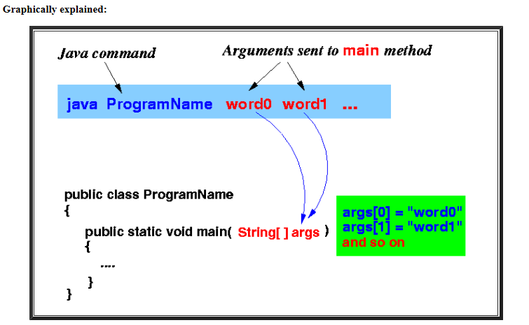

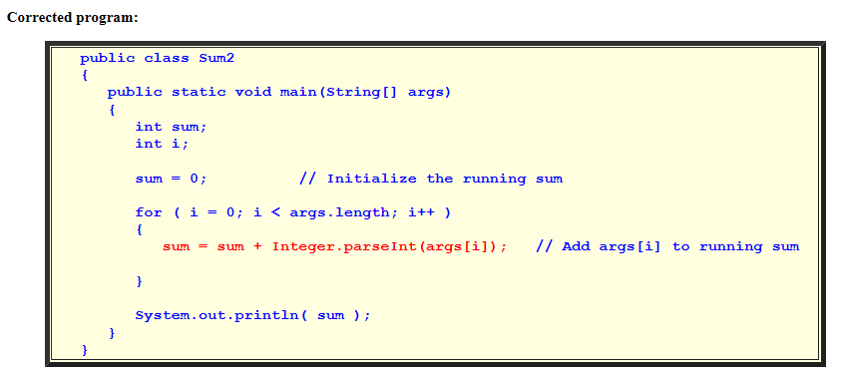

Converting String to double
  - A numeric string can be converted into an double using the parseDouble method in the Double class.
The parseDouble method is invoked as follows:
Double.parseDouble( NumericString )
The parseDouble method returns an double precision value of the numeric string
Note:

If we run a Java Program by writing the command “java Hello Geeks At GeeksForGeeks” where the name of the class is “Hello”, then it will run upto Hello. It is command upto “Hello” and after that i.e “Geeks At GeeksForGeeks”, these are command line arguments.
When command line arguments are supplied to JVM, JVM wraps these and supply to args[]. It can be confirmed that they are actually wrapped up in args array by checking the length of args using args.length
// Program to check for command line arguments
class Hello{
public static void main(String[] args) {
// check if length of args array is
// greater than 0
if (args.length > 0) {
System.out.println("The command line"+
" arguments are:");
// iterating the args array and printing
// the command line arguments
for (String val:args)
System.out.println(val);
}
else
System.out.println("No command line "+
"arguments found.");
}
}
When executed as following:
java Hello Geeks at GeeksforGeeks
Output:
The command line arguments are:
Geeks
at
GeeksforGeeks
When executed as following:
java Hello
Output:
No command line arguments found.

